Building A DNA Model

The structure of DNA is similar to a spiral staircase. Notice that the “backbone” (or railing) is made of alternating sugars (deoxyribose) and phosphate molecules, and the “steps” are made of the base groups (Adenine, Thymine, Guanine and Cytosine).

In this activity, you will build a DNA model. You will be given a sheet of paper with various shapes; these shapes will represent different parts of the DNA molecule. The circles will represent the phosphate groups, the rectangles will represent the bases, and the hexagons will represent the sugars.
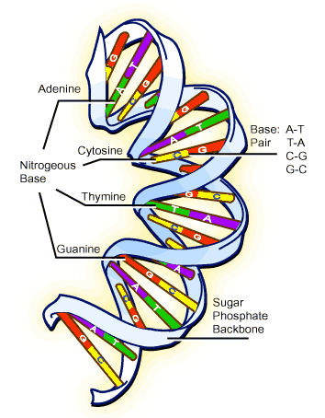
PROCEDURE:

- Look at the attached sheet. In the center of the deoxyribose molecules (pentagon shape) write the letter S (for sugar). In the center of the phospahte molecule (circle shape) write the letter P (for phosphate). On each base (rectangle) write a different letter, either A, T, C or G making sure that you have even amounts of A –T and G-C.

- Color the deoxyribose sugars and the phosphate groups. Choose one different color for both the deoxyribose molecules and the phosphate groups. For example, all of the deoxyribose molecules should be the same color. Once the pieces are colored, cut them out.

- Lay out the backbone (alternating P and S molecules). Be sure to leave space for the bases.

- Next color the bases. Designate each base a different color. Make sure there are even amounts of bases. So for example if you have 8 A’s you need to have 8 T’s. Once the pieces are colored, cut them out.

- Lay out the bases in the spacing between the DNA backbones. Make sure bases are only touching the deoxyribose sugar. Remember, the complementary base pairs should fit together like puzzle pieces!

- Once you have your DNA laid out in the correct order, THEN glue the pieces to the paper to construct your DNA model.

- Using the sequence of DNA bases you have, determine the complementary RNA strand.

- Using the chart below, determine which Amino Acids you have based on the complimentary RNA strand. Remember that there may be more than one codon for each amino acid. If there are multiple options, choose one.

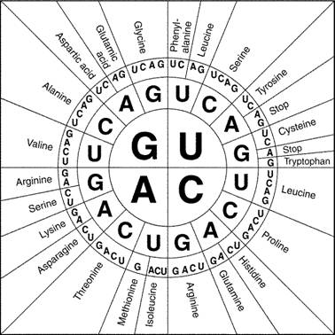
To use this chart, the first base is in the center, the second base is the next row towards the outside and the third base is the outer most row.
For example:
DNA RNA Amino Acid
TAU AUC Isoleucine (ILE)

