PROJECT: Creative Cells
MYP Biology Unit 4 Evidence
STEPS FOR SUCCESS:

- Get in your group and assign roles:
***Note: You are all responsible for the entire project and will be graded as a group. These roles are just your ‘specialties’ to aid with collaboration.

ROLE | NAME | RESPONSIBILITIES
Director |  | - Provides guidance and makes sure team is on-task.  - References RUBRIC to ensure ADVANCED work!
Photographer |  | - Uses his/her cellphone appropriately as equipment.  - Takes and SAVES all of the pictures.
Producer |  | - Focuses on big-picture and the scientific accuracy!  - Helps compile final project.
Designer |  | - Designs “characters” and backgrounds for project.  - Assists with set movement.

- Create your storyboard:
- This does not have to be well-drawn, but it should be detailed!
- Check that you are meeting all rubric requirements and that the science is correct!

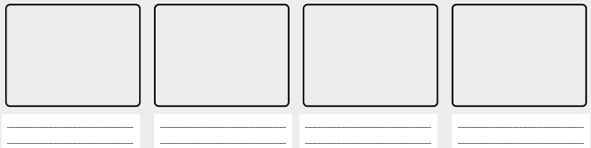
- Get your storyboard approved by your teacher: __________________________________

- Make your characters/backgrounds.
- HINTS: Also make a title AND credits!

- Take your pictures!
- Never move the camera once you start taking pictures.
- Move the paper or clay about 1 inch for each movement.

- Upload all pictures to Movie Maker. ***See steps sheet!

- Add music/special effects if time allows.

- Email FINAL project to _________________ = _________________@milwaukee.k12.wi.us
_ _ _ _ _ _ _ _ _ _ _ _ _ _ _ _ _ _ _ _ _ _ _ _ _ _ _ _ _ _ _ _ _ _ _ _ _ _ _ _ _ _ _ _ _ _ _ _ _ _ _ _ _ _

Rubric for PROJECT: Creative Cells

Criteria A: Knowing and Understanding

Achieve - ment Level | Level Descriptor  The student is able to: | Specifics for PROJECT: Creative Cells  The video includes:
0 | The student does not reach a standard identified by any of the descriptors below.
Minimal  MI | - State scientific knowledge  - Apply scientific knowledge and understanding to suggest solutions to problems set in familiar situations  - Interpret information to make judgments. | - Definitions of mitosis OR meiosis  - Steps of mitosis OR meiosis  - No real-world connections  - Minimal creativity and effort  - 3 or more scientific errors
Basic  BA | - Outline scientific knowledge  - Apply scientific knowledge and understanding to solve problems set in familiar situations  - Interpret information to make scientifically supported judgments. | - Definitions of mitosis OR meiosis  - Steps of mitosis OR meiosis  - A real-world connection for EITHER mitosis OR meiosis  - Creative ideas and genuine effort  - 1-2 scientific errors
Proficient  PR | - Describe scientific knowledge  - Apply scientific knowledge and understanding to solve problems set in familiar situations and suggest solutions to problems set in unfamiliar situations  - Analyze information to make scientifically supported judgments. | - Definitions of mitosis and meiosis  - Steps of mitosis AND meiosis  - A real-world connection for EITHER mitosis OR meiosis  - Creative ideas and genuine effort  - ALL scientifically accurate material
Advanced  AD | - Explain scientific knowledge  - Apply scientific knowledge and understanding to solve problems set in familiar and unfamiliar situations  - Analyze and evaluate information to make scientifically supported judgments. | - Definitions of mitosis and meiosis  - Detailed steps of mitosis AND meiosis  - A real-world connection for BOTH mitosis AND meiosis (IE: cancer, genetics, etc.)  - Unique ideas and genuine effort  - ALL scientifically accurate material

You ROCK!

