Unit 2b: Cell Division Part II Meiosis I and Meiosis II

**Meiosis Word Meanings**

* **Homologous**
  + **Etymology: ________ *homologos* : to agree**
  + **having the** ____________ **position, value, or** _______________
* **Tetrad**
  + **Etymology: _________**
  + **a group or arrangement of four**
* **Centromere**
  + **Centro*= ______________* mere= *______________***
* **Dyad** 
  + **Etymology: Late** __________ ***dyas,* from** ____________**, from *dyo***
  + **: ________ __________ individuals**
* **-ploid** 
  + **having or being a** ___________________
* **Di-**
  + **Etymology: Latin, from Greek; the same as Old English *twi-***
  + **twice : two : double**
* **Ha-** 
  + **Etymology: Greek *haploeidēs* single**

Somatic cells and Gametes

* + Somatic cells are _____________________________.
    - Make up most of your _______________________________
    - These are diploid (2n)
      * Have two sets of chromosomes
      * ____ set from father &____ set from mother
  + Gametes = sex cells(sperm/egg cells)
    - These are haploid (n)
      * Have only ____________ set of chromosomes
  + Types of Chromosomes
    - Autosomes – contain genes __________________________________________________
    - Sex chromosomes – directly controls __________________________________________

**Meiosis I**

Interphase

* Cell starts off as a diploid cell

= Diploid (2n)______________________________________________________________________

* G1 – ______________________; DNA is long and stringy (so the DNA can be copied) and is ________________.
* S – DNA _________________________________________________________________
* G2 – Cell continues growing and ______________________________________________

Prophase I

1. The _______________________________________________________________________________________.
2. Centriols create Spindle Fibers
3. Nuclear envelope disappears
4. ___________________________________________________________________________________________



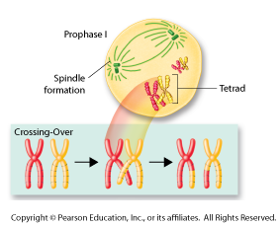

Metaphase I

1. The spindle fibers attach to the **centromere** on each chromosome pair.
2. Homologous chromosomes are lined up on the metaphase plate (equator) by the spindle fibers.
3. ___________________________________________________________________________________________

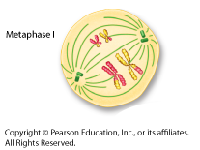

Anaphase I

1. ___________________________________________________________________________________________
2. 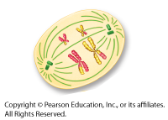Each homologous chromosome moves to opposite poles.

Telophase I / Cytokenesis

1. 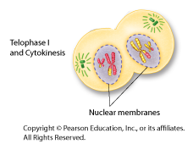Individual nuclear envelopes begin to surround the separate chromosomes
2. Cytokenesis separates the two cells

END OF MEIOSIS I

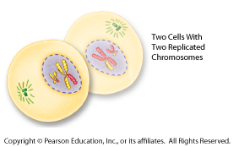 ___________________________________________________________________________________________

**Meiosis II**

Prophase II

1. _____________________________________________________________________________________.
2. 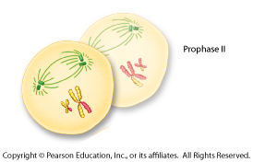Nuclear envelope disappears
3. The centrioles create spindle fibers.

Metaphase II

1. The spindle fibers attach to the **centromere** on each ________________________________________________.
2. The _______________ are lined up on the metaphase plate (equator) by the spindle fibers.
3. ___________________________________________________________________________________________

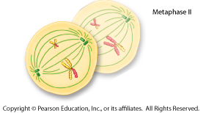

Anaphase II

1. The individual sister chromatids from each dyad get pulled apart by the spindle fibers
2. 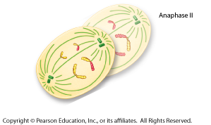Each sister chromatid ends up on opposite poles of the cell

Telophase II / Cytokenesis

1. The ________________________________________________________________________________
2. ___________________________________________________________________________________________
3. The _________________________________________________________________________________
4. ___________________________________________________________________________________________

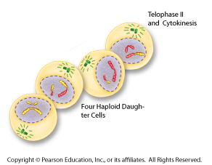

END OF MEIOSIS II

Four _______________________ cells are created, each with a half set of chromosomes compared to the original (***Original _______________________________________________________***).

= Haploid (n): _________________________________________________________________________

