MYP Biology – Unit 3: Data Analysis #1 Name: __________________Block:_____ Assignment #:_____
- Make two graphs with the following experiment information (ecosystem #1 and #2).
A greenhouse built in the Arizona desert in the USA, has been used to study different ecosystems. It is a closed system so measurements can be made under controlled conditions. The data shown below were collected over the course of one day in January 1996.
Ecosystem #1
Concentration of CO₂ (ppm) | Time (hours)
110 | 2
140 | 4
285 | 6
310 | 8
390 | 10
410 | 12
420 | 14
480 | 18
310 | 20
280 | 22
100 | 24
Ecosystem #2
Concentration of CO₂ (ppm) | Time (hours)
0 | 2
50 | 4
90 | 6
150 | 8
210 | 10
440 | 12
590 | 14
640 | 18
430 | 20
210 | 22
50 | 24
- Make a conclusion regarding the two graphs.
..........................................................................................................................................................
..........................................................................................................................................................
..........................................................................................................................................................
...........................................................................................................................................................
..........................................................................................................................................................
...........................................................................................................................................................
............................................................................................................................................................
............................................................................................................................................................
...........................................................................................................................................................
...........................................................................................................................................................
..........................................................................................................................................................
...........................................................................................................................................................
............................................................................................................................................................
............................................................................................................................................................
...........................................................................................................................................................
...........................................................................................................................................................
..........................................................................................................................................................
...........................................................................................................................................................
............................................................................................................................................................
............................................................................................................................................................
...........................................................................................................................................................

MYP Biology – Unit 3: Data Analysis #2 Name: __________________Block:_____ Assignment #:_____
1. The rate of photosynthesis in the marine seagrass, Zostera marina, was investigated under a range of pH conditions. After a period of darkness, the plants were illuminated at a constant light intensity at 15°C and the rate of photosynthesis was measured. Zostera marina can use both dissolved carbon dioxide (CO2) and hydrogen carbonate ions for photosynthesis. The rate of photosynthesis is plotted on the y-axis on the left. In addition, the concentration of carbon dioxide was measured for each pH investigated and is plotted on the y-axis on the right.
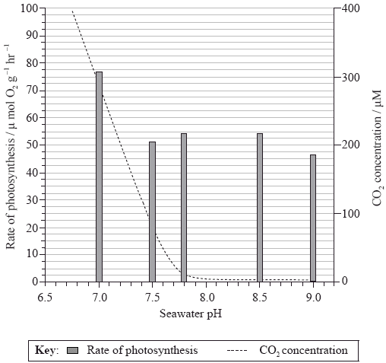
(a) State the carbon dioxide concentration at pH 7.2.
......................................................................................................................................
(1)
(b) Calculate the percentage decrease in the rate of photosynthesis from pH 7 to pH 7.5.
......................................................................................................................................
......................................................................................................................................
(1)
(c) Outline the relationship between pH and the rate of photosynthesis.
......................................................................................................................................
......................................................................................................................................
......................................................................................................................................
(2)

2. The effect of temperature on photosynthesis was studied in sweet orange (Citrus sinensis) using leaf discs. The production of oxygen was used to measure the rate of photosynthesis.
Gross photosynthesis refers to the sum of net photosynthesis and respiration. Net photosynthesis was calculated by subtracting the rate of respiration in the dark from gross photosynthesis.
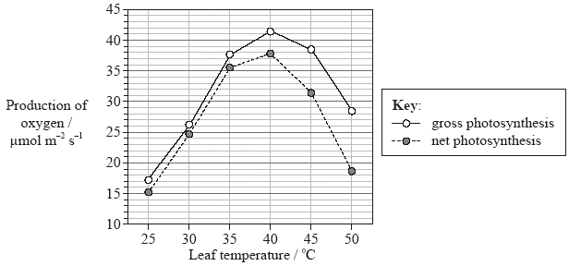
(a) Identify the optimum temperature for photosynthesis in this plant.
......................................................................................................................................
(1)
(b) Determine the difference between gross photosynthesis and net photosynthesis at 40°C and 50°C.
40°C: ..........................................................................................................................
50°C: ..........................................................................................................................
(2)
(c) Deduce what happens to the rate of respiration as the temperature increases between 40°C and 50°C.
......................................................................................................................................
(1)
(d) Compare the effect of temperature on photosynthesis with the effect of temperature on respiration in sweet orange.
...........................................................................................................................
...........................................................................................................................
...........................................................................................................................
...........................................................................................................................
...........................................................................................................................
(3)

Biology 9 – Unit 3: Data Analysis Practice #1

1. (a) 200 μM (units required) 1
(b) (77–51)/77×100 = 35% (Units required. Allow answers
in the range of 32–37%.) 1
(c) highest rate of photosynthesis at pH 7;
decrease (in rate of photosynthesis) between pH 7 and pH 7.5;
little change (in rate of photosynthesis) at higher pH values;
rate of photosynthesis falls again (slightly) at pH 9; 2 max

2. (a) 40°C 1

(b) 40°C: 3.5 µmol m–2 s–1; (units required)
Accept answers between 3.0 µmol m–2 s–1 and 4.0 µmol m–2 s–1.
50°C: 10 µmol m–2 s–1; (units required) 2
Accept answers between 9 µmol m–2 s–1 and 11 µmol m–2 s–1.

(c) rate of respiration is increasing 1

(d) rate increases as the temperature increases up to a point/40°C
and then decreases 1
at low temperatures/between 25°C and 35°C the rate of
photosynthesis increases and the rate of respiration is
(approximately) constant;
between 35°C and 40°C both increase;
as temperature continues to increase the rate of
photosynthesis reaches optimum whereas rate of respiration
decreases less/stays constant/increases;
at high temperatures/between 40°C and 50°C photosynthesis
decreases as respiration decreases less/stays constant/increases; 2 max
[7]

