Unit 5: Classification

1. Classification
   1. ________________________________________________________________________
   2. ________________________________________________________________________
   3. **Taxonomy:**
      1. _________________________________________________________________
      2. Taxonomist: Person who studies taxonomy
         1. **Aristotle**(384-322B.C.)Greek Philosopher
            1. Recognized for creating Biological Classifications in two Groups:
            2. Plants = ____________________________________________
            3. Animals = __________________________________________
         2. **Linnaeus**- Swedish Botanist (1707-1778)
            1. ___________________________________________________
            2. ___________________________________________________
   4. **Binomial nomenclature**- two-word naming system to identify species
      1. 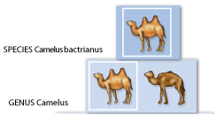Genus – _______________________________________________
      2. Specific epithet- ________________________________________
         1. Example: ___________________

***H****omo sapiens*

*(****Genus*** */specific epithet)*

*\*\*Scientific names should be italicized in print and underlined when hand written*

*\*\*****First letter of Genus name is upper case*** *but the second letter of the specific epithet is lower case*

1. Modern Classification
   1. _____________________________________________________________________
   2. _____________________________________________________________________
   3. Group organisms
      1. Example: Bangle Tigers and Saber-tooth tigers
      2. **_______________________________________________________________**
2. Taxonomic Rankings
   1. Organisms are ranked in **taxa**
      1. ________________________________________________________________
   2. The more inclusive a taxon the more general the characteristics and more species it contains
   3. The more exclusive the taxon the more specific the characteristics and fewer species they will contain.
      1. The Different Taxa
         1. _____________________________________________________________
         2. Key moves from, more general (top) to, more specific (bottom)
            * There are more organisms found in KINGDOM than in ______________
            * 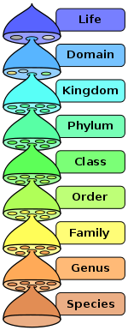There are more organisms found in PHYLUM than in _______________

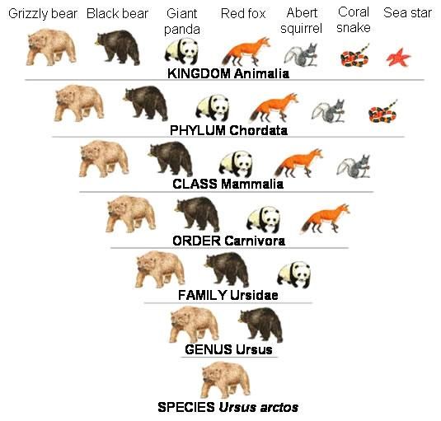**Taxonomic Classification of a Grizzly Bear**

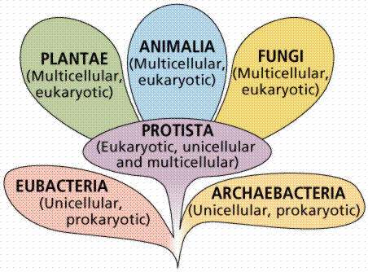

1. Kingdoms
   1. Six Major Kingdoms
      1. Animals: 3 million species = __________
         * ___________________________________________
         * ___________________________________________
         * Heterotrophs- ______________________________________________________
      2. Plants: 0.5 million species = __________
         * ______________________________________________
         * _________________________________________________
         * Autotrophs- _______________________________________________________
      3. Fungi: 100,000 species = _________
         * __________________________________________________
         * ___________________________________________________
         * Heterotrophic - _____________________________________________________
      4. Protists: 70,000 species = _________
         * ___________________________________________________
         * some have __________________, some _________
         * Some are ___________________ some are ____________________or both.
      5. Archaebacteria 500 species = ________
         * _____________________________________________________
         * _____________________________________________________
         * Live in ___________________________
      6. Eubacteria 10,000 species = _________
         * ______________________________________________________
         * ______________________________________________________
         * live _____________________________.
   2. How are Kingdom relationships determined?
2. 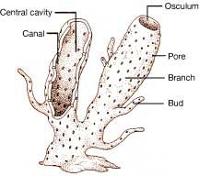Structural similarities
   * 1. Asymmetrical
        + _________________________________________________
          1. Ex. Sponges
     2. 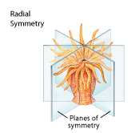Radially symmetrical
        + ________________________________________________
          1. Ex. Sea anemone
     3. 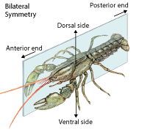Bilaterally symmetrical
        + ______________________________________________

Ex. Lobster / Most animals-insects we see

1. Phylogenetic Classification – Structural similarities
   * What is Cladistics?
     1. ___________________________________________________
     2. 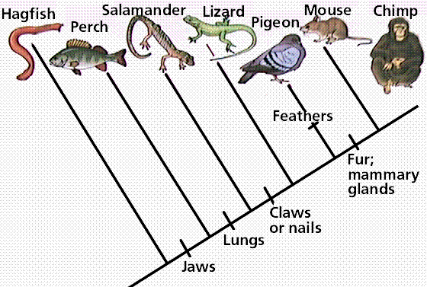___________________________________________________
   * What is a Cladogram?
     1. Branching diagram
     2. _________________________________________
2. Breeding behavior
   * _____________________________________________________
   * _____________________________________________________
3. Geographical distribution
   * Location of species on earth ________________________________________________.
4. Chromosome comparisons
   * The number of __________________________ (______________ of DNA) an organism has.
   * The ___________________ of those _______________________
5. Biochemistry – DNA code
   * _______________________________________________________________________
6. What is Evolution?
   1. ______________________________________________________________________________
      1. ________________________________________________________________________
      2. ________________________________________________________________________
7. What is Natural Selection?
   * 1. ________________________________________________________________________
     2. How Natural Selection works.
        1. Genetic variations must ______________________________________________
        2. Some of those variations are more ____________________________________

__________________________________________________________________

* + - 1. __________________________________________________________________
      2. __________________________________________________________________



1. Charles Darwin (1809-1882)
   * First person ____________________________________________________________________
   * Gradualism: ____________________________________________________________________
     1. ________________________________________________________________________
     2. occurs when individuals with the _____________________________________________

___________________________________________________________________________

* + Organisms ____________________________________________________________________
  + Genetic Drift**:**
    1. _______________________________________________________________________

1. Evolution of Species
   * Speciation:
     1. Formation of a ____________________- a ____________ barrier in breeding must occur
     2. Division of a single species into ______________________________________________
   * Reproductive Isolation
     1. Genetic material _________________________________________________________
     2. Occurs when formally _____________________________________________________

_______________________________________________________________________

* + - 1. Example: Behavioral – ______________________________________________

_________________________________________________________________

* + Speciation Rates
    1. Punctuated Equilibrium:
       1. __________________________________________________________________
       2. Ex. Elephants species stemming from the same one

1. Evidence of Evolution
   * Fossil Records
     1. Evidence of the ___________________________________________________________
   * Anatomy
     1. Homologous Structures
        1. ______________________ in different species derived from the same body parts
        2. The ______________________________________________________________
        3. Example: __________________
     2. Vestigial Organs
        1. ____________________________________________________________________________________________________________________________________
        2. Example: Tonsils
     3. Analogous Structures
        1. ______________________________________________________________
        2. Example: ________________________
   * Adaptations
     1. Camouflage
        1. Protective _________________________________________________________
     2. Mimicry
        1. ____________________________________________________________________________________________________________________________________
   * Genetics
     1. DNA between _________________________________________________

# **The Human Body**

# **Protection, Support, & Locomotion**

1. Integumentary System
   1. Skin: _____________________________________________________
   2. Two layers: Epidermis and Dermis
   3. Composed of four types of body tissues
      1. Epithelial - ___________________________________________
         1. Functions to _______________________________________________________
      2. Connective - Consists of both tough and flexible protein fibers
         1. Serves as __________________________________________________________
      3. Muscle
         1. Interacts with ______________________________________________________
      4. Nervous
         1. Helps us ___________________________________________________________
   4. Epidermis: outermost layer
      1. ____________________________________________________ that are continually being shed
   5. Dermis: second principal layer
      1. Vascularized: ___________________________________________________________________
   6. Subcutaneous layer
      1. _______________________________________
      2. Attaches ______________________________________________________ (muscles) & tissues
   7. Functions:
      1. Help maintain _______________________by regulating your internal body temperature
2. Skeletal System
   1. 206 Bones – 300 bones in babies
      1. Framework for the tissues of your body
      2. ______________________________________________________________
   2. Bone cells
      1. Ossification: ____________________________________________________
3. Muscular System
   1. Types
      1. Smooth muscle
         1. Walls of your _______________________________________________
         2. Functions: _________________________, exerting pressure on the space inside the organ it surrounds to __________________________________
         3. ____________________________________________________
      2. Cardiac muscle
         1. Heart - ______________________________________________
      3. Skeletal muscle
         1. _____________________________________________________

# **Circulatory System**

# I. Blood

* + 1. Red blood cells
       1. Transport ______________________________________________
       2. Lack a ______________________
       3. Contains ____________________
    2. White blood cells
       1. _______________________________________________________

1. Pathway of Circulation
   1. Three main types of blood vessels
      1. Arteries
         1. Elastic blood vessel that ____________________________________________________
      2. Capillaries
         1. Form a dense network that _________________________________________________
      3. Veins
         1. Large blood vessels that ____________________________________________________

# **Respiratory System**

1. Functions
   1. Process of _________________________
      1. Mechanisms involving ____________________________________________________________
2. Alveoli
   1. Alveoli= ______________________________________________________________________________
3. Mechanics
   1. ___________________________________________________ enable you to breathe in and breathe out
   2. Diaphragm is located ______________________________________________
4. Control of Respiration
   1. ________________________________________________________
   2. Medulla oblongata = ____________________________________________________________
      1. Responds to ____________________________________________________________________
      2. Nerve signals cause these _________________________________________________________

**Digestive System**

1. Functions
   1. Disassemble food ______________________________________________________________________
2. Digestive Tract
   1. Mouth
      1. Mechanical digestion: ______________________________ of breaking food into smaller pieces
      2. Saliva: contains _________________________________________________________________
   2. Esophagus
      1. Connects _____________________________________
      2. Epiglottis: ______________________________________________________________________
   3. Stomach : Food remains in your stomach for __________________________________
      1. Lined with ___________________________
      2. Chemical digestion : Gastric juices: _____________________________________
      3. Mechanical digestion : ________________________________
      4. ___________________________________________________ to protect from the gastric juices
   4. Small Intestine : Muscular tube _________________________________________________
      1. Chemical digestion: ____________________________________________________
         1. Enzymes secreted by the ___________________________________________________
         2. Bile: ____________________________________________________________________
      2. Absorption
         1. Liquid stays in your small intestines ___________________________________________
   5. Large Intestine
      1. _______________________________________ goes to the large intestine
      2. Water absorption
         1. Water and salts are _______________________________________________________
         2. Vitamin synthesis _________________________________________________________
      3. Elimination of wastes
         1. 18 to 24 hours in the ______________________________________________________. 24 to 36 hours for ______________________________________

**Nervous System**

1. Basic unit: ______________________________________
   1. Conduct ____________________________________________________________________________
   2. Neuron is a long cell that consists of three regions
      1. _________________________________
      2. ________________________: ___________________________ & carry them toward the body
      3. __________________: ___________________________________________ from the cell body
2. **CNS** : central nervous system – ___________________________
   1. Anatomy of the Brain
      1. Cerebrum
         1. divided into __________________________
         2. controls _________________________________________________________________
      2. Cerebellum
         1. _____________________________________
         2. controls ___________________________________ - if injury movements become jerky
      3. Brain stem
         1. medulla oblongata: _______________________________________________________
3. **PNS:** peripheral nervous system
   1. Two divisions
      1. Somatic system: _______________________________________ your CNS and skeletal muscles
      2. Autonomic system: ______________________________________________________________

**Immune System**

I. Terminology

A. Pathogens – _____________________________________________________: Viruses/Bacteria/Fungi/Protist

B. Antigens – ________________________________________________________________________________

C. Antibodies – proteins manufactured by the immune system ________________________________________

* Each type recognizes _______________________ & responds by dividing rapidly to form clones

D. Immunity

* Active immunity – _______________________________________________________________
* Passive immunity – ______________________________________________________________
* Natural immunity – ______________________________________________________________
* Artificial immunity - ______________________________________________________________

II. Non-specific defense

1. skin and mucous membranes = ___________________________________________________________
   1. _________________________________________ so microbes can’t colonize
   2. mucous traps ___________________________________________________________________
   3. saliva – ____________________________________________ / stomach – _________________
2. White Blood Cells (WBC)
   1. phagocytes – cells that ________________________________– contain l___________________
   2. macrophages – large WBC that are able to ____________________________________________ in through the process of __________________________________
3. Inflammatory Response
   1. Local injury or infection
      1. vasodilation near injury or infection _________________________________________
      2. increased ______________________________________________________________
4. The Thirty-six Animal Phyla

|  |  |  |  |  |
| --- | --- | --- | --- | --- |
| Phylum | Examples | Body Plan | Feeding  Reproduction | Interesting Facts |
| [Acanthocephala](http://en.wikipedia.org/wiki/Acanthocephala) |  |  | ------------------------- |  |
| [Acoelomorpha](http://en.wikipedia.org/wiki/Acoelomorpha) |  |  | ------------------------- |  |
| [Annelida](http://en.wikipedia.org/wiki/Annelida) |  |  | ------------------------- |  |
| [Arthropoda](http://en.wikipedia.org/wiki/Arthropoda) |  |  | ------------------------- |  |
| [Brachiopoda](http://en.wikipedia.org/wiki/Brachiopoda) |  |  | ------------------------- |  |
| [Bryozoa](http://en.wikipedia.org/wiki/Bryozoa) |  |  | ------------------------- |  |
| [Chaetognatha](http://en.wikipedia.org/wiki/Chaetognatha) |  |  | ------------------------- |  |
| [Chordata](http://en.wikipedia.org/wiki/Chordata) |  |  | ------------------------- |  |
| [Cnidaria](http://en.wikipedia.org/wiki/Cnidaria) |  |  | ------------------------- |  |
| [Ctenophora](http://en.wikipedia.org/wiki/Ctenophora) |  |  | ------------------------- |  |
| [Cycliophora](http://en.wikipedia.org/wiki/Cycliophora) |  |  | ------------------------- |  |
| [Echinodermata](http://en.wikipedia.org/wiki/Echinodermata) |  |  | ------------------------- |  |
| [Echiura](http://en.wikipedia.org/wiki/Echiura) |  |  | ------------------------- |  |
| [Entoprocta](http://en.wikipedia.org/wiki/Entoprocta) |  |  | ------------------------- |  |
| [Gastrotricha](http://en.wikipedia.org/wiki/Gastrotricha) |  |  | ------------------------- |  |
| [Gnathostomulida](http://en.wikipedia.org/wiki/Gnathostomulida) |  |  | ------------------------- |  |
| [Hemichordata](http://en.wikipedia.org/wiki/Hemichordata) |  |  | ------------------------- |  |
| [Kinorhyncha](http://en.wikipedia.org/wiki/Kinorhyncha) |  |  | ------------------------- |  |
| [Loricifera](http://en.wikipedia.org/wiki/Loricifera) |  |  | ------------------------- |  |
| [Micrognathozoa](http://en.wikipedia.org/wiki/Micrognathozoa) |  |  | ------------------------- |  |
| [Mollusca](http://en.wikipedia.org/wiki/Mollusca) |  |  | ------------------------- |  |
| [Nematoda](http://en.wikipedia.org/wiki/Nematoda) |  |  | ------------------------- |  |
| [Nematomorpha](http://en.wikipedia.org/wiki/Nematomorpha) |  |  | ------------------------- |  |
| [Nemertea](http://en.wikipedia.org/wiki/Nemertea) |  |  | ------------------------- |  |
| [Onychophora](http://en.wikipedia.org/wiki/Onychophora) |  |  | ------------------------- |  |
| [Orthonectida](http://en.wikipedia.org/wiki/Orthonectida) |  |  | ------------------------- |  |
| [Phoronida](http://en.wikipedia.org/wiki/Phoronida) |  |  | ------------------------- |  |
| [Placozoa](http://en.wikipedia.org/wiki/Placozoa) |  |  | ------------------------- |  |
| [Platyhelminthes](http://en.wikipedia.org/wiki/Platyhelminthes) |  |  | ------------------------- |  |
| Porifera |  |  | ------------------------- |  |
| [Priapulida](http://en.wikipedia.org/wiki/Priapulida) |  |  | ------------------------- |  |
| [Rhombozoa](http://en.wikipedia.org/wiki/Rhombozoa) |  |  | ------------------------- |  |
| [Rotifera](http://en.wikipedia.org/wiki/Rotifera) |  |  | ------------------------- |  |
| [Sipuncula](http://en.wikipedia.org/wiki/Sipuncula) |  |  | ------------------------- |  |
| [Tardigrada](http://en.wikipedia.org/wiki/Tardigrada) |  |  | ------------------------- |  |
| [Xenoturbellida](http://en.wikipedia.org/wiki/Xenoturbellida) |  |  | ------------------------- |  |
| **Total: 36** |  |  |  |  |